|  |  |  |
| --- | --- | --- |
|  | Q.1 | As per Java servlets concepts, which of the following methods will you use to specify before any lines that use the PrintWriter?   * setPageType() * setContextType() * setContentType() * setResponseType()   Hide Options   * Answer :C **setContentType**() |
|  | Q.2 | As per Java servlets concepts, what is the purpose of RequestDispatcher object?   * Includes other resources * Includes an image * Includes an XML object * Includes an email response   Hide Options   * Answer A: Includes other resources |
|  | Q.3 | As per Java servlets concepts, which of the following statements about the status of the HTTP response is true?   * A status of 200 to 299 signifies that the request was successful. * A status of 300 to 399 specifies informational messages. * A status of 400 to 499 indicates an error in the server. * A status of 500 to 599 indicates an error in the client.   Hide Options   * Answer A: A status of 200 to 299 signifies that the request was successful. |
|  | Q.4 | Given are some methods of HttpServletResponse that may be used to get the appropriate writer/stream object. As per Java servlets concepts, which of these will you use to send text output in a response?   * getStream() * getOutputStream() * getBinaryStream() * getWriter()   Hide Options  ANSWER D : getWriter() |
|  | Q.5 | As per Java servlets concepts,​ which of the following statements for POST method while using HTML forms, is true?   * POST allows users to bookmark URLs with parameters. * The POST method should not be used when large amount of data needs to be transferred. * POST allows secure data transmission over the HTTP method. * POST method sends data in the body of the request.   Hide Options |
|  | Q.6 | As per Java servlets concepts, within a war file, compiled class files can be located at which of the following options?   * /META-INF/classes * /classes * /WEB-INF/classes * /root/classes   Hide Options  Q5.C  Q6 . C /WEB-INF/classes |
|  | Q.7 | As per Java servlets concepts, which of the following actions will trigger an HTTP request on the client side?   * Entering username/password and clicking the submit button * Clicking a hyperlink displayed in the HTML page * Using Javascript's API such as reload() to refresh the current page * All of the given options   Hide Options   * Answer A: Entering username/password and clicking the submit button   Not sure |
|  | Q.8 | As per Java servlets concepts, which of the following methods will you use to send a response in the form of character data to the client?   * HttpServletRequest.getWriter() * HttpServlerResponse.getCharacterWriter() * HttpServetRequest.getOutputStream() * HttpServletResponse.getWriter()   Hide Options   * Answer :D HttpServletResponse.getWriter() |
|  | Q.9 | As per Java servlets concepts, which of the following interfaces provides access to the method, getRequestedSessionId()?   * HttpSession * HttpServletRequest * HttpServletResponse * ServletContext   Hide Options   * Answer : HttpServletRequest |
|  | Q.10 | As per Java servlets concepts, which of the following options is recommended for storing the initialization parameters pertaining to the servlets in a distributed environment?   * The values of the initialization parameters can be stored in the application itself * The values have to be externalized to other storage locations like database or a file * The storage of the values to any location doesn't have any impact in a distributed environment * None of the given options   Hide Options  Answer : The values of the initialization parameters can be stored in the application itself |
|  | Q.11 | What is the number of ServletContext objects available for a Web application?   * One each per servlet * One each per request * One each per response * Only one for the entire session   Hide Options   * Ans : D |
|  | Q.12 | You would use which of the following options to dispatch the servlet to another resource out of context?   * requestDispathcer * sendRedirect * Both of the given options * None of the given options   Hide Options   * Answer B: sendRedirect |
|  | Q.13 | Which of the following options is thread-safe?   * Context scoped variables * Session scoped attributes * Instance variables in a servlet * Local variables in doService()   Hide Options |

* ANSWER ; Local variables in doService()

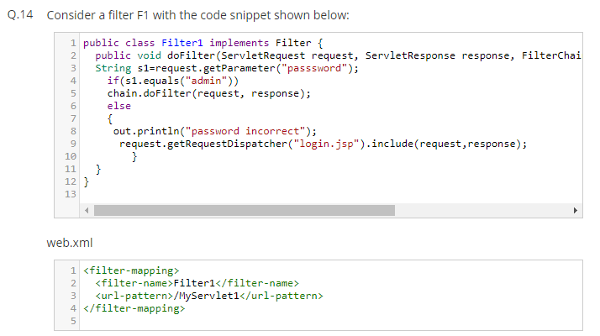



Answer : A Authentication Filter

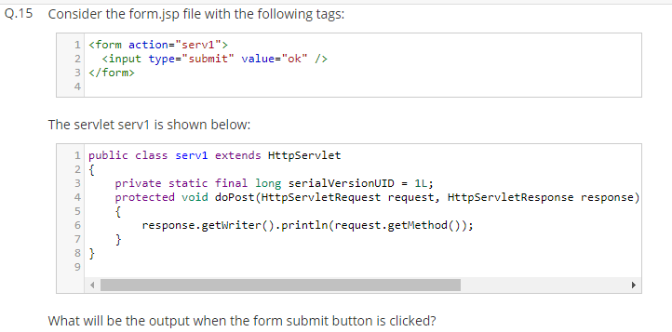

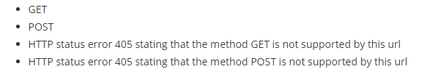

A NSWER : GET